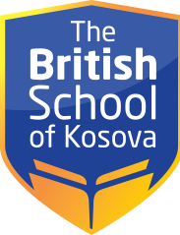

SCHEDULE – CLASS IV/A
CLASS | MONDAY | TUESDAY | WEDNESDAY | THURSDAY | FRIDAY
1 | English | Art | Albanian | Physical education | Physical education
2 | English | Mathematics | Mathematics | English | Albanian
3 | Mathematics | Albanian | Mathematics | Mathematics | Mathematics
4 | Music | English | English | Mathematics | English
5 | Albanian | English | English | Albanian | English
6 | Society and the environment | Human and nature | Elective subject | Human and nature | Society and the environment

