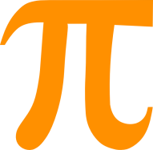
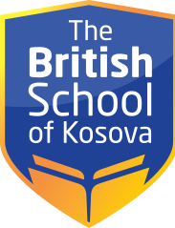

SCHEDULE – CLASS I/A
CLASS | MONDAY | TUESDAY | WEDNESDAY | THURSDAY | FRIDAY
1 | Albanian | Albanian | Mathematics | Albanian | Music
2 | Mathematics | English | Mathematics | Physical Education | Albanian
3 | Mathematics | English | English | English | Physical Education
4 | English | Art | English | English | English
5 | English | Mathematics | Albanian | Mathematics | Mathematics
6 | Science | Social studies | Science | Social studies | Science

