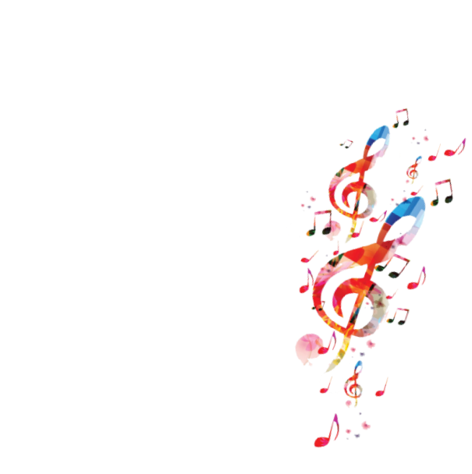
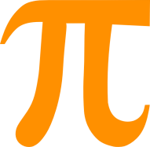
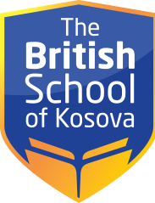

TIMETABLE – CLASS 4/A
CLASS | MONDAY | TUESDAY | WEDNESDAY | THURSDAY | FRIDAY
1 | Mathematics | PE | Mathematics | PE | English Language
2 | Albanian Language | English Language | Mathematics | Mathematics | English Language
3 | English Language | Mathematics | Albanian Language | English Language | Mathematics
4 | Music | Art | English Language | English Language | Mathematics
5 | English Language | Albanian Language | English Language | Science | Albanian Language
6 | Social studies | Science | Handcraft | Albanian Language | Social studies

