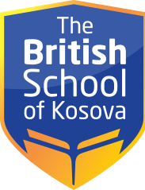

SCHEDULE–CLASS V/A
CLASS | MONDAY | TUESDAY | WEDNESDAY | THURSDAY | FRIDAY
1) 09:20-10:00 | English | Albanian | Mathematics | Music | Physical education
2) 10:10-10:50 | English | Mathematics | Mathematics | Mathematics | English
3) 11:00-11:40 | Albanian | Art | English | Albanian | English
4) 12:35-13:15 | Mathematics | English | Albanian | English | Albanian
5)13:20-14:00 | Mathematics | Physical education | English | English | Mathematics
6)14:05-14:45 | Society and the environment | Human and nature | Elective subject | Human and nature | Society and the environment

