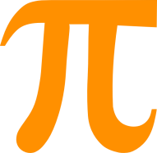
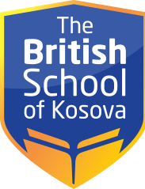

SCHEDULE – CLASS ll/A
CLASS | MONDAY | TUESDAY | WEDNESDAY | THURSDAY | FRIDAY
1 | Physical  education | Music | Art | Mathematics | Albanian
2 | English | Mathematics | Physical  education | Albanian | Mathematics
3 | English | Mathematics | Mathematics | English | Mathematics
4 | Mathematics | Albanian | English | English | English
5 | Albanian | English | English | Social studies | English
6 | Social studies | Science | Albanian | Science | Science

